# Induction

* Recall the induction principle:

If such that,

1. is true
2. is true ⇒ is true

Then is true

Exercise:

1. Prove that

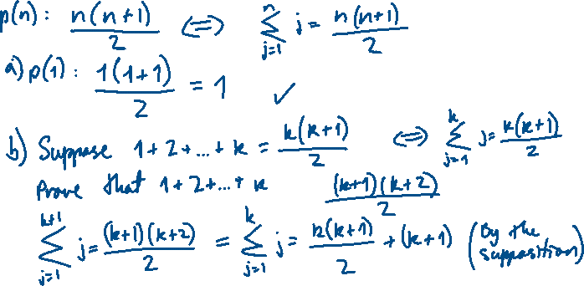

1. Prove that

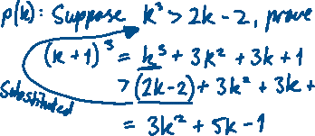

1. Prove that

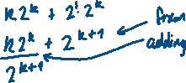

1. Prove that (a|b: “a divides b”)



## Sigma Notation

We use capital sigma to shorten notation of long sums:

Exercise:

Expand



Exercise:

Simplify



* By the laws of addition, we have the following properties:

1)

2)

## Generalised Mathematical Induction

* Let be defined for all , and let . If

1. is true, and
2. For all is true ⇒ is true

Then is true for all

Exercise:

Is ?



Exercise:

Prove that.



## Recursive Sequences

* A sequence of numbers is defined recursively if each for is defined in terms of some or all of .

Exercise:

Let . Find and .



Exercise:

The Fibonacci numbers are the numbers in the famous sequence:

This sequence is defined by:

Can we show that ?



## Strong Mathematical Induction

* Let be defined for all m let if:

1. are true, AND
2. For all is true ⇒ is true,

Then is true for all .

Exercise:

For the Fibonacci sequence , prove that



Exercise:

Let Prove that

